

**Experiment No. 8**

**Title:** Password Cracking - Burp suite, Cain and Abel

(A Constituent College of Somaiya Vidyavihar University)

**Batch: A4 Roll No.: 16010420066 Experiment No.: 8**

**Aim:** To implement password cracking using Burp suite and Cain and Abel

**Resources needed:** Burp suite Professional, Cain Abel open source tool

**Theory**

**Procedure / Approach /Algorithm / Activity Diagram:**

**Implementation:**

Task1: Explain dictionary attack step by step using Burp Suite (Including screen shots) Task2: Explore any web exploit step by step using Cain Abel (Including screen shots)

**Questions:**

1) What is the difference between Burp suite and open source Cain Abel? (Justify your answer with features).

**Result:** Screenshots of task 1 and 2 demonstrating the activity**.**

Open Burp Suite and start proxy:

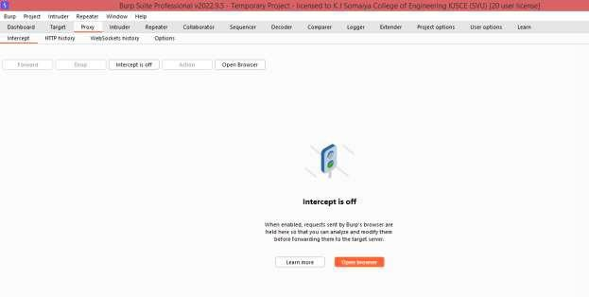

Used test website :<http://altoro.testfire.net/login.jsp>to perform dictionary attack using burp suite

Intercept form submission packet and send to intruder

Chosen attack type cluster bomb:

Added payload markers to username and password

Added Payloads

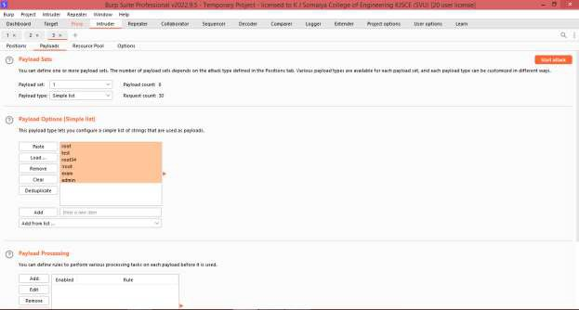

Started attack

Attack successful

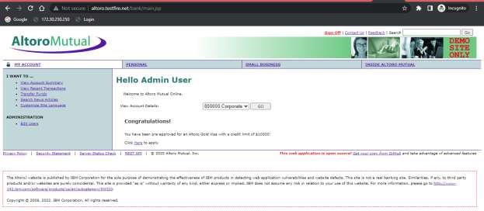

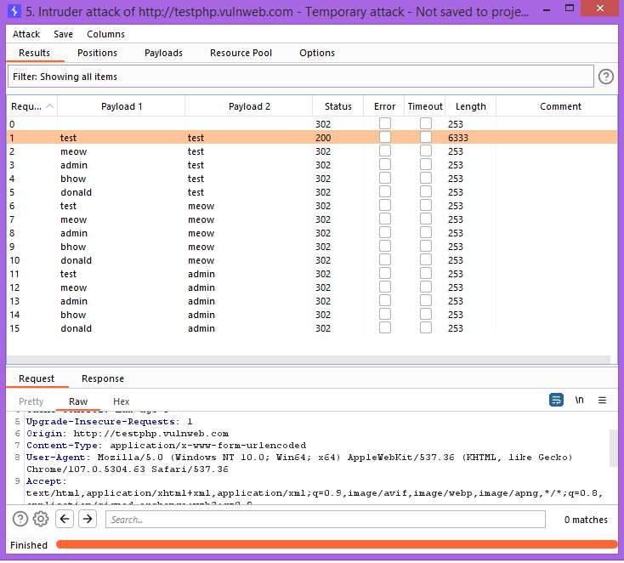

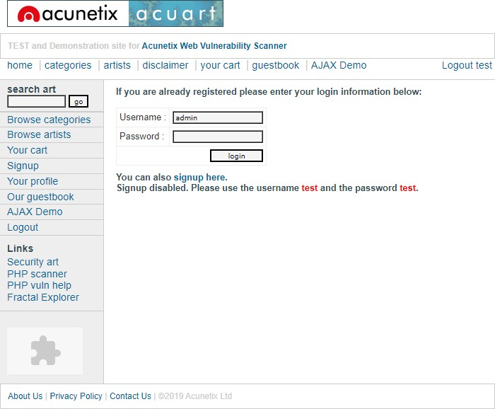

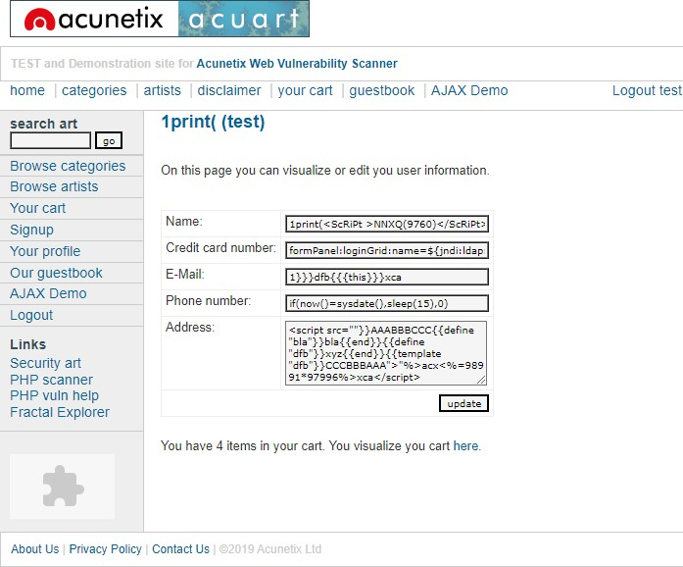

Postlab:

1. What is difference between burpsuite and cain abel?

Ans: Burp or Burp Suite is a set of tools used for penetration testing of web applications while cain abel is password recovery tool.

**Outcomes:**

CO4: Understand Security issues related to Software, Web and Networks.

**Conclusion: (**Conclusion to be based on the objectives and outcomes achieved**)**

Attacks using burpsuit is implemented successfully.

**Grade: AA / AB / BB / BC / CC / CD /DD**

**Signature of faculty in-charge with date**

**References:**

**Books/ Journals/ Websites:**

* 1. [**https://en.wikipedia.org/wiki/Cain_and_Abel_(software)**](https://en.wikipedia.org/wiki/Cain_and_Abel_(software))
  2. [**https://www.darknet.org.uk/2007/01/cain-and-abel-download-windows-password-cracker/**](https://www.darknet.org.uk/2007/01/cain-and-abel-download-windows-password-cracker/)
  3. [**https://sectools.org/tool/cain/**](https://sectools.org/tool/cain/)
  4. [**https://portswigger.net/burp/pro**](https://portswigger.net/burp/pro)